Transactional Leadership

The transactional style of leadership was first described by Max Weber in 1947 and then by Bernard Bass in 1981. This style is most often used by the managers. It focuses on the basic management process of controlling, organizing, and short-term planning. The famous examples of leaders who have used transactional technique include McCarthy and de Gaulle.

Definition of Transactional Leadership

Transactional leadership styles are more concerned with maintaining the normal flow of operations. Transactional leaders use disciplinary power and an array of incentives to motivate employees to perform at their best.

The term “transactional” refers to the fact that this type of leader essentially motivates subordinates by exchanging rewards for performance.

A transactional leader does not look ahead to strategically guiding an organization to a position of market leadership; instead, these managers are solely concerned with making sure everything flows smoothly today.

A leadership style based on the setting of clear goals and objectives for followers and the use of rewards and punishments to encourage compliance.
Transactional leaders are those who guide or motivate their followers towards established goals by clarifying role and task requirements.

Dimensions of transactional leadership

The leader believes in motivating through a system of rewards and punishment. If a subordinate does what is desired, a reward will follow, and if he does not go as per the wishes of the leader, a punishment will follow. Here, the exchange between leader and follower takes place to achieve routine performance goals.
These exchanges involve four dimensions:

- Contingent Rewards: Transactional leaders link the goal to rewards, clarify expectations, provide necessary resources, set mutually agreed upon goals, and provide various kinds of rewards for successful performance. They set SMART (specific, measurable, attainable, realistic, and timely) goals for their subordinates.
- Active Management by Exception: Transactional leaders actively monitor the work of their subordinates, watch for deviations from rules and standards and taking corrective action to prevent mistakes.

- Passive Management by Exception: Transactional leaders intervene only when standards are not met or when the performance is not as per the expectations. They may even use punishment as a response to unacceptable performance.
- Laissez-faire: The leader provides an environment where the subordinates get many opportunities to make decisions. The leader himself abdicates responsibilities and avoids making decisions and therefore the group often
lacks direction.

Assumptions of Transactional Theory

- Employees are motivated by reward and punishment.
- The subordinates have to obey the orders of the superior.
- The subordinates are not self-motivated. They have to be closely monitored and controlled to get the work done from them.

Transactional leadership emphasizes results, stays within the existing structure of an organization and measures success according to that organization’s system of rewards and penalties.

Transactional leaders hold the formal authority and positions of responsibility in an organization. And responsible for maintaining routine by managing individual performance and facilitating group performance.

Functions of Transactional Leader

Transactional, or managerial, leaders set the standards for workers and do performance reviews are the most common way to judge employee performance. Transactional leaders are expected to do the following:

- Set goals and give specific direction about what they demand from the employee and how they will be rewarded for their efforts.

- Provide productive feedback on performance.

- Focus on increasing the efficiency of established routines and procedures and show concern for following existing rules rather than making changes.

- Establish and standardize practices that will help the organization become efficient and productive.

- Respond to deviations from expected outcomes and identify corrective actions to improve performance.

Transactional leadership sometimes referred to as managerial leadership; focuses on the interactions between leaders and followers. The core of transactional leadership lies in the notion that the leader, who holds power and control his or her employees or followers, provides incentives for followers to do what the leader wants.

Transactional leaders utilize rewards and punishments to motivate their followers. While it has limitations, it can be effective in certain situations.
A transactional style can work well in cases where the problems are clear-cut and simple.

One of the major problems with this style is that it does not encourage group members to look for solutions to problems or to contribute creatively, which is why transactional leadership is not the best choice in complex situations where input from group members is required.

Characteristics of Transactional Leadership
- Celebrate inefficiency.
- Very left-brained.
- Tend to be inflexible.
- Opposed to change.
- Focused on short-term goals.
- Favour structured policies and procedures.
- Thrive on following rules and doing things correctly.

Advantages of Transactional leadership
- Awards those who are motivated by self-interest to follow instructions.

- It gives an unambiguous structure for large organizations, systems requiring repetitive tasks and infinitely reproducible environments.
- Achieves short-term goals quickly.
- Rewards and penalties are defined by workers.

Disadvantages of Transactional leadership
- Rewards the worker on a practical level only, such as money or perks.
- Creativity is limited since the goals and objectives are already set.
- It does not reward personal initiative.

Examples of transactional leadership
The transactional leadership model is likely to succeed in a crisis or in projects that require linear and specific processes. This model is also useful for big corporations, such as Hewlett-Packard, a company known for its extensive use of management by exception.

Many high-level members of the military, CEOs of large international companies, and NFL coaches are known to be transactional leaders. Transactional leadership also works well with policing agencies and first responder organizations.

Bill Gates is a great example, of a transactional leader. Bill Gates is now one of the richest and most influential people in the world. As a transactional leader, he used to visit new product teams and ask difficult questions until he was satisfied that the teams were on track and understood the goal.

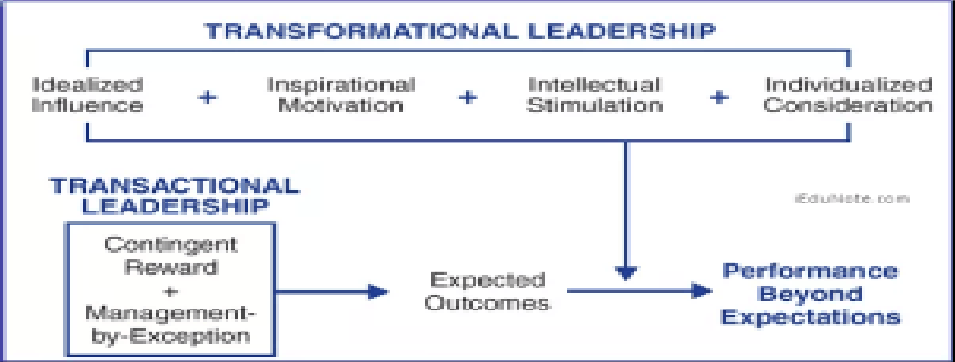
Difference Between Transactional and Transformational Leadership

The transactional leaders (or managers) ensure that routine work is done reliably, while the transformational leaders look after initiatives that add value.

Transactional leaders provide distinct advantages through their abilities to address small operational details, quickly.

Transactional leaders handle all the details that come together to build a strong reputation in the marketplace while keeping employees productive on the front line.
Transformational leadership styles are crucial to the strategic development of a small business.

Small businesses with transformational leaders at the helm shoot for ambitious goals, and can they achieve rapid success through the vision and team-building skills of the leader.

Difference between Transactional and Transformational Leadership

Transactional and transformational are the two modes of leadership that tend to be compared the most.

James Mac-Gregor Burns distinguished between transactional leaders and transformational by explaining that: a transactional leader is a leader who exchanges tangible rewards for the work and loyalty of followers.
Transformational leaders are leaders who engage with followers, focus on higher-order intrinsic needs, and raise consciousness about the significance of specific outcomes and new ways in which those outcomes might be achieved.

Transactional Leadership | Transformational Leadership
In this case Leadership is responsive. | In this case Leadership is proactive.
Works within the organizational  culture. | Works to change the organizational  culture by implementing new ideas.
Employees achieve objectives through rewards and punishments set by the  leader. | Employees achieve objectives through higher ideals and moral values.

Motivates followers by appealing to  their self-interest. | Motivates followers by encouraging  them to put group interests first.
Management-by-exception  maintain the status quo; stress correct actions to improve performance. | Individualized consideration Each behaviour is directed to each individual to express consideration and  support.
Intellectual stimulation or motivation is zero. | Intellectual stimulation  Promote creative and innovative ideas to solve problems.

Conclusion

Creating a high-performance workforce has become increasingly important and to do so business leaders must be able to inspire organizational members to go beyond their task requirements.

As a result, new concepts of leadership have emerged transformational leadership is one of them. In many organizations, both transactional and transformational leadership are needed. The transactional leaders ensure that routine work is done reliably, while the transformational leaders look after initiatives that add value.

